Name: _____________________ Class:__________ Date:__________
Instructions: Write answers in the right-hand column. Score: ___________ / 54 marks
Section A— Multiple choice (10 marks)

 | Granite is a rock that consists of crystals formed:  A by evaporation of liquid from a solution.  B of molten material from the mantle or lower crust.  C by heat and pressure acting on rocks.  D by extremely rapid cooling of igneous material at the surface. | B | 1
 | Igneous rocks are:  A made of rounded grains cemented together.  B left behind when a solution evaporates.  C formed from eroded sediment.  D made of interlocking crystals. | D | 1
 | Rock that forms from the cementing of deposited particles is called:  A metamorphic rock.  B igneous rock.  C sedimentary rock.  D volcanic rock. | C | 1
 | A metamorphic rock is formed by the:  A slow cooling of molten magma to form large crystals.  B deposition and cementing of eroded particles.  C rapid cooling of molten magma to form crystals.  D effects of great heat and pressure on rock. | D | 1
 | Gabbro is a dark-coloured intrusive igneous rock. A reasonable prediction is that:  A crystals in gabbro are difficult to see.  B all the crystals squashed into lines.  C the crystals are quite large.  D the rock has many holes in it. | C | 1
 | The two most common processes that change a pile of sediment into a sedimentary rock are:  A compaction and cementation.  B weathering and erosion.  C deposition and sedimentation.  D cooling and crystallisation. | A | 1
 | The first type of rock to form in the Earth’s crust was most likely:  A sedimentary.  B metamorphic.  C igneous.  D clastic sedimentary. | C | 1
 | The water holding capacity of soils will be greater if:  A there is a lot of clay in the soil.  B there are large pore spaces in the soil.  C there are large crumbs.  D the soil contains a lot of sand. | A | 1
 | The structure of a soil refers to:  A the size of the particles.  B how well the soil particles join up into crumbs.  C how fast water enters the soil.  D the tendency of soil particles to stick together. | B | 1
 | Coal is a sedimentary rock that forms when:  A plants fall into lava and become burned to a black charcoal.  B bacteria in soil partially decompose and leave behind a black residue.  C tiny ancient single celled organisms became buried under soil that turned into rock.  D plants are buried and compressed between rock layers. | D | 1

Section B— Short answer (34 marks)

- ` | Explain how the three different types of sedimentary rocks are formed. | clastic: weathered rock particles are cemented together  chemical: evaporation of moisture  organic: remains of organisms become deposited and cemented together | 3
 | The following are a list of different rocks that have properties as described. Identify them as igneous, sedimentary or metamorphic.  A shale: strongly layered and fragile, splitting into flat sheets of soft fine particles  B basalt: very hard rock of small dark crystals  C breccia: large sharp angled particles cemented by many fine rounded particles  D limestone: soft rock with very small rounded white coloured grains including fossil shells found in an ocean reef  E granite: very hard rock of large crystals of three different colours, white, light grey and black  F gneiss: wavy dark lines set in light coloured rock, the elongated crystals are all lined up parallel to each other | A sedimentary  B igneous  C sedimentary  D sedimentary  E igneous  F metamorphic | 3
 | Complete the missing labels on the diagram of the rock cycle below.  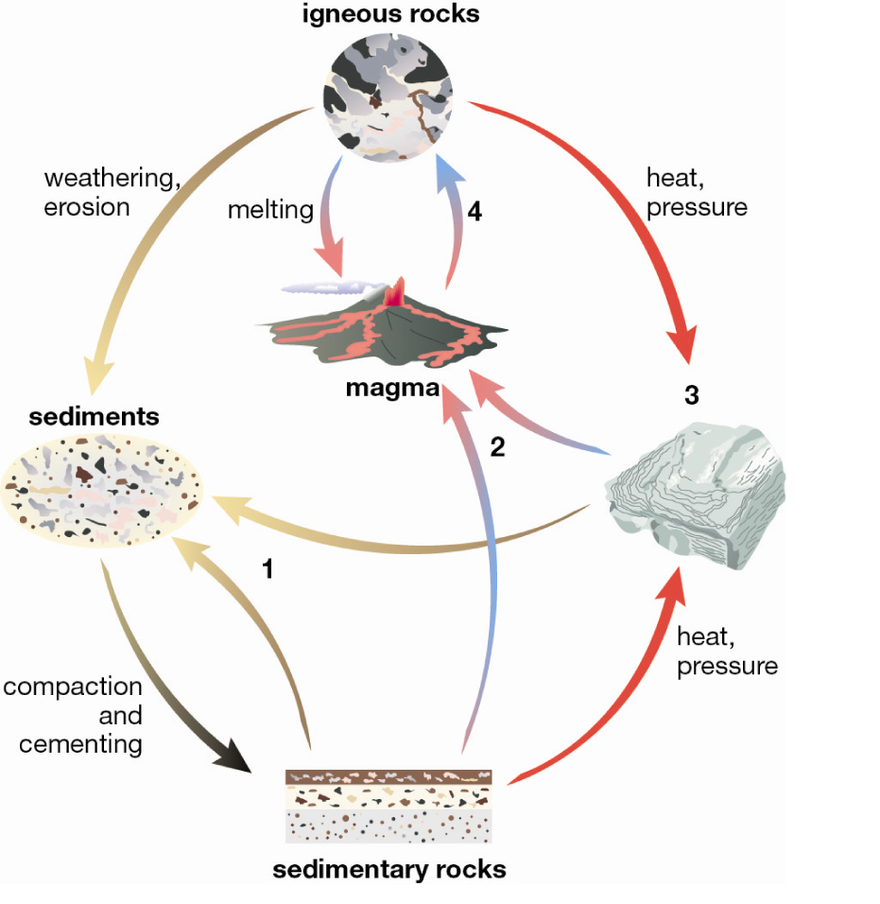 | 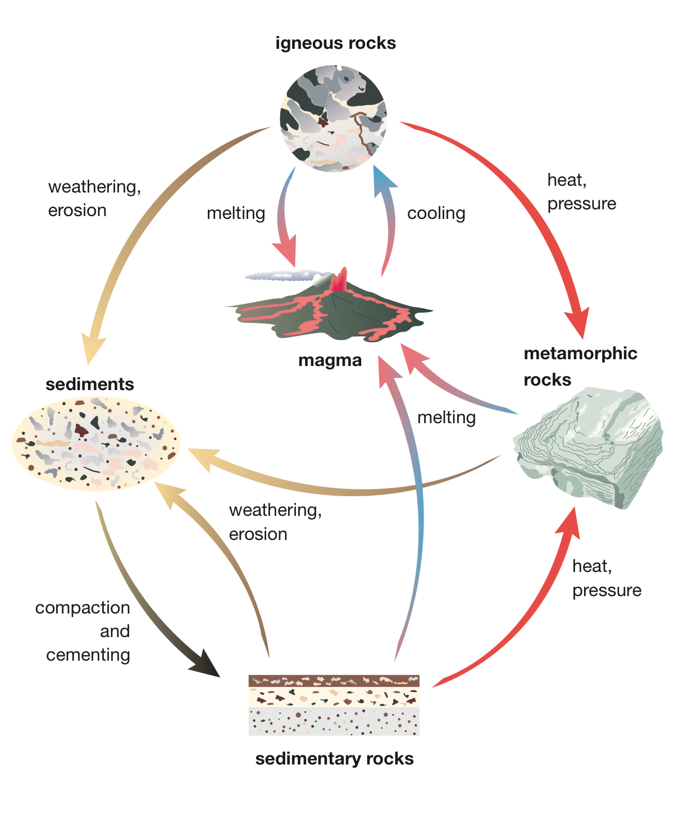 | 3
 | Granite and basalt are both igneous rocks.  a Describe the major difference between the texture of these two rock types.  b Explain what causes this difference in texture.  c Explain why the colour is different in the two rocks. | a the size of the crystals: granite has large crystals that are visible to the eye; the crystals in basalt can only be seen clearly with a microscope  b granite cooled slowly, while basalt cooled quickly  c they are made from different minerals that have different colours | 3
 | a Define weathering  b Describe weathering by temperature change  c Describe one way weathering can occur by ice  d Contrast erosion and weathering. | a Breakdown of rocks into smaller pieces  b Rapid temperature change can cause a rock to expand and contract fast, which can split the rock  c Water can enter cracks in the rock and when the water freezes, it expands and splits the rock. (Or, students could discuss glaciers scraping smaller pieces off rocks.)  d Weathering breaks pieces off rocks, erosion is the removal of the pieces once they are broken off. | 4
 | Describe the two main ways in which metamorphism occurs. | Regional metamorphism occurs over a wide area—where landmasses are colliding, and also in all the rocks at the bottom of the crust. The great pressure of overlying rocks and the heat below the crust combine to change rocks.  Contact metamorphism occurs where magma pushes through cracks in the crust in a local area and changes the rocks there. | 3
 | a Name the three most common natural agents of erosion.  b Describe one effect that one of these agents of erosion would have on farmland. | a water, wind and ice  b Wind or water can strip the paddocks of topsoil so that there are no nutrients for growing crops. Floodwaters can strip paddocks of all vegetation. | 2
 | Use the sedimentary rock classification key below to answer these questions.  a Using the information in the key, describe limestone.  b State the major difference between siltstone and mudstone.  c Compare siltstone and conglomerate.  d Gemma found a rock with grains in it that were easily visible and of roughly the same size (0.5 mm). Identify this rock.  e Tyrone found a rock that he recognised as a mudstone, and it had abundant fossil shells in it. Assess the limitations of this key in light of Tyrone’s discovery. | a Limestone is described in this key as a rock that consists mostly of animal skeletons and fizzes in acid.  b The grains in mudstone are smaller than those that make up siltstone.  c Both siltstone and conglomerate are made up of rock fragments.  d sandstone  e The key would not correctly identify the rock as it has features of both limestone and mudstone.
 | 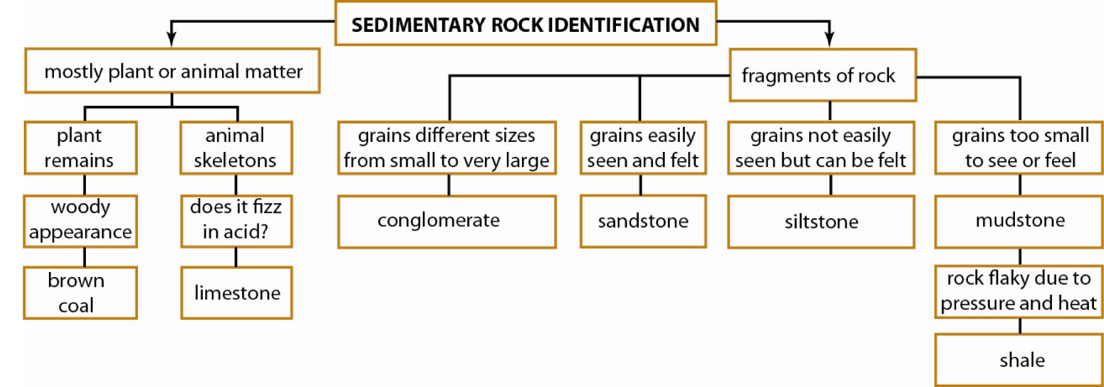 |  | 5
 | Explain why crystal size in igneous rocks is affected by how fast rock cools. | Slow cooling (over millions of years) produces large crystals because the particles can move around and keep adding to a nearby crystal, which then continues to grow bigger.  Fast cooling (in days or years) does not allow particles enough time to move to large crystals growing nearby and add to these. Instead, they form lots of tiny crystals. Some form no obvious crystals. | 4
 | Emerson and Jaya collected sediment from four different places along the course of a river. They made a sketch map of the river with the sampling locations, and they labelled the bottles of sediment. Identify which sediment samples match which location, and explain your four choices.  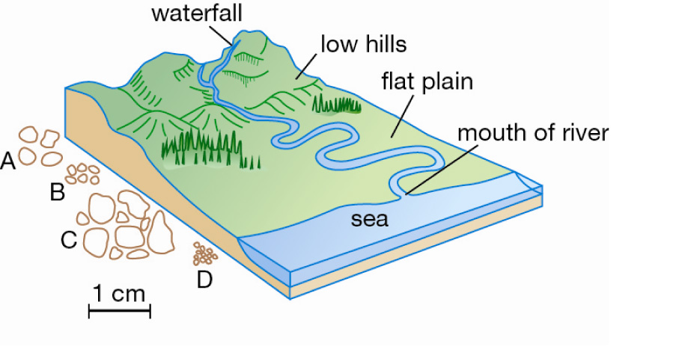 | Sample A is from the low hills. The grains are still large, but are rounded from travelling.  Sample B is from the winding part of the river on the flat plain. The grains have been worn small and very rounded from constant rolling in the water.  Sample C is from the mountain waterfall. The sediment has large pieces consistent with a high-energy environment, and they have not yet travelled far enough after being smashed to be rounded.  Sample D is from the mouth of the river. The water has become quieter and quieter and only fine grains are being transported now. | 4

Section C— Thinking scientifically (10 marks)

 | When rocks are heated under very high pressure, many minerals form into flattened sheets. However, quartzite and marble are two common metamorphic rocks that do not show any flattening of the crystals. Quartzite is formed from sandstone and has interlocking grains. Marble is formed from limestone, and the crystals tend to be fused together.  A likely conclusion from this information is that these two rocks:  A were not heated enough to melt.  B were formed by contact metamorphism but not deep in the crust.  C were formed under high pressure, but without heating.  D were not formed by metamorphic processes. | B | 1
 | The cliff face in the diagram below shows rocks corresponding to a number of geological processes that have operated in the area over millions of years.  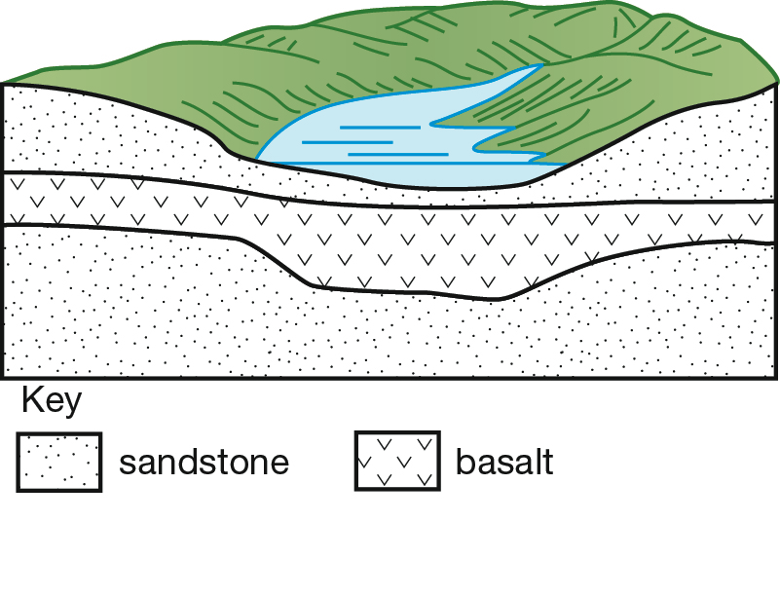  To answer this question, you will need to use this key:  E = erosion  D = deposition  RF = rock formation  V = volcanic eruption  Which sequence describes the geological history of this area?  A D, E, RF, V, D, E  B D, V, RF, E, D, E  C D, RF, E, V, RF, D, RF, E  D E, D, V, RF, E, D, RF | C | 1
 | Which of the following diagrams shows how layers of rock fragments would be deposited in a lake after heavy rain had washed them downriver?  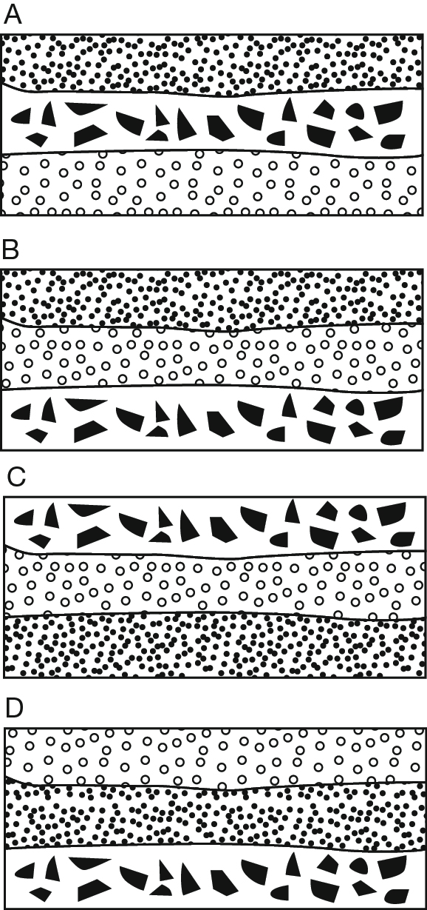 | B | 1
 | Marika and Michael are going to build their first home out of local rocks. They visit some quarries looking for hard, weather-resistant rock for the walls of their house, some rock that will make nice flat roof tiles, a hard-wearing attractive rock for the benchtops in the kitchen, and a soft, pale rock with an even colour and fine texture for an indoor statue that Michael wants to carve in his spare time. To do all of these jobs, which of the following is the best choice of rocks?  A conglomerate, siltstone, mudstone, limestone  B granite, sandstone, coal, basalt  C conglomerate, mudstone, shale, marble  D basalt, slate, granite, marble. | D | 1
 | Gerhard the geologist found a rock that consisted of large pebbles held together by mud and sand grains, and some gypsum. This rock most likely formed from:  A sediment that had accumulated for many years in a creek that was subject to occasional flooding.  B cooling magma deep in the Earth’s crust.  C sediment that piled up in an ocean beach dune.  D swamp deposits. | A | 1
 | Dean and Musa were experimenting with a model stream and how much soil it can wash away. They changed the angle of a slope and measured the soil loss in a 10 minute period. They made the following measurements.  A reasonable deduction from these results is:  A Fast streams will carry 640 g of sediment.  B A moderate slope will lose 275 g of sediment every 10 minutes.  C Faster streams will cause more erosion.  D Twice as much sediment is carried if a stream flows twice as fast. | C | 1
  Steepness of slope | Stream speed (m/s) | Mass of particles lost (g) | Largest particle size (mm)
  gentle | 1 | 48 | 10
  moderate | 4 | 283 | 40
  steep | 8 | 640 | 100
 | When soil is compacted by heavy vehicles driving over it, its ability to support plant growth is greatly reduced. The reason for this is:  A the plant nutrients are squeezed out of the soil.  B the pore space is reduced so water and air cannot enter.  C the crumbs are broken down and so less nutrients can be held in the soil.  D the permeability increases so the plants become waterlogged and die from lack of oxygen. | B | 1
 | Most house bricks are made from clay. When the clay is heated to a very high temperature, the clay minerals melt and stick to each other before setting into a solid. This process is much like the formation of:  A igneous rocks from metamorphic rocks.  B metamorphic rocks from sedimentary rocks.  C sedimentary rocks from igneous rocks.  D sedimentary rocks from metamorphic rocks. | B | 1
 | Some students set up the following experiment to investigate how well water percolates into soil. They planned to pour water into the filter funnels and measure how much water entered the conical flasks. When they tried their experiment, it did not work. No water entered the conical flasks.  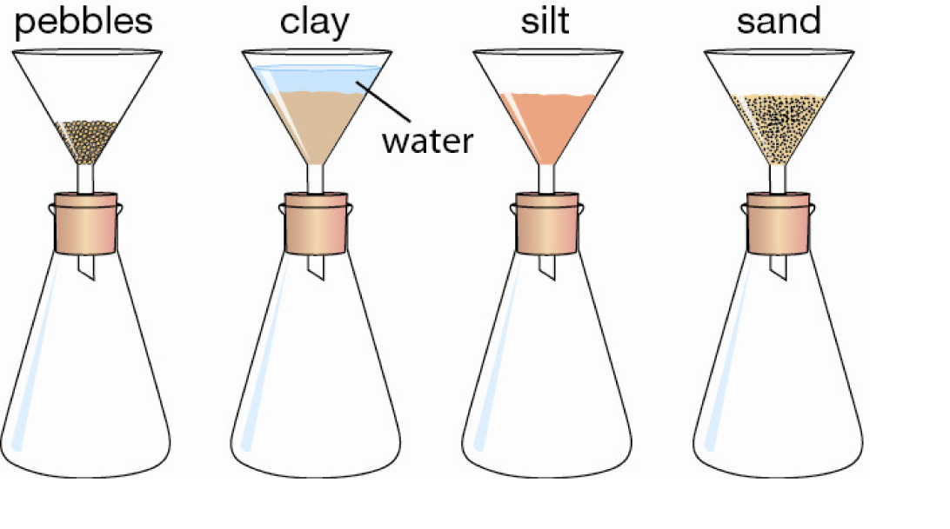  The reason why it did not work is that:  A water will not drain through the soils they tried.  B they did not pour enough water into the funnels and it was all absorbed by the soil.  C the filter funnel stem was too narrow to allow water to pass through it.  D there was air in the conical flasks and it could not escape to let the water in. | D | 1
 | When a substance is heated enough, it will melt. However, if the pressure can be kept high enough, the substance may not melt. Diamonds form deep below the crust, 150 km down in the mantle. When parts of the crust sink into the mantle, they melt. Then the diamonds are rapidly lifted up to the surface by rising magma when the crust cracks. How can diamonds form so deep and yet remain solid?  A The pressure is much higher deeper in the Earth.  B The diamonds are brought up faster than they can become heated enough to melt.  C Diamonds cool fast as they are brought up by the rising magma, and this turns them into solid.  D It is cooler deeper in the Earth and so the diamonds will stay solid. | A | 1

